Mercy Health Saint Mary’s
Grand Rapids, Michigan

NURSING SERVICE DIVISION POLICY AND PROCEDURE

Index Code: 340/012
Date of Original P&P: 4/11
Effective Date: Draft 4/18
Revision Number: 1

ORIGINATOR: Nursing Service

APPROVAL: ________________________________
Vice President & Chief Nursing Officer

TITLE: PREOPERATIVE PATIENT CARE ORDERS

POLICY STATEMENT: Preparing a patient for surgery can be a complex process. The evidence based literature shows patients with certain risk factors need defined laboratory tests the day of surgery to assure optimization prior to anesthesia. This policy facilitates surgical care by allowing nurses in the Pre-Admission Screening (PAS) and preoperative areas to initiate appropriate preoperative testing and other interventions in preparation for surgery. The surgery scheduling request is the written order for the Registered Nurse to initiate the orders within this policy.

General Provisions:
- Low risk surgical procedures need NO specific pre-op testing (that includes no pre-op labs or ECG) unless the patient is symptomatic, i.e. short of breath, complaining of chest pain or palpitation, etc. Low risk surgical procedure patients will have day of surgery (DOS) testing done if applicable.
- Blood level testing is not required for patients receiving Anticonvulsants, Digoxin, or Lithium.
- For the safety of the patients who may require possible intra/post-operative blood transfusion, a type and screen will be drawn preoperative (prior to date of surgery) for identified Intermediate and High Risk Surgical procedures. The type and screen must be within 10 days of the surgical procedure. ** [Exception: Patients who have been transfused within the last 90 days or have been pregnant within the last 90 days need their T&S drawn within 3 days of scheduled surgical procedure]**.
- Type and screen must be done at a Trinity Health facility.

PROCEDURE:

Responsibility Action

Registered Nurse 1. Checks the surgery scheduling request for the preoperative patient care orders.

2. Reviews patient chart for previous lab work/completed orders.

Note: Assuming stable clinical condition, laboratory work and ECG done within 6 months of surgery are acceptable.

3. Uses addendum to determine patient specific labs for day of service.

4. Orders the appropriate lab tests/interventions in Cerner using written order designation with the ordering physician (the surgeon who signed the surgery scheduling request).

References:
Apfelbaum, J. L., Connis, R. T., Nickinovich, D. G., Pasternak, L. R., Arens, J. F., Caplan, R. A., ... & Rice, L. J. (2012). Practice advisory for preanesthesia evaluation: an updated report by the American Society of Anesthesiologists Task Force on Preanesthesia Evaluation. Anesthesiology, 116(3), 522-538.

Chow, W. B., Rosenthal, R. A., Merkow, R. P., Ko, C. Y., & Esnaola, N. F. (2012). Optimal preoperative assessment of the geriatric surgical patient: a best practices guideline from the American College of Surgeons National Surgical Quality Improvement Program and the American Geriatrics Society. Journal of the American College of Surgeons, 215(4), 453-466.

Feely, M. A., Collins, C. S., Daniels, P. R., Kebede, E. B., Jatoi, A., & Mauck, K. F. (2013). Preoperative testing before noncardiac surgery: guidelines and recommendations. American family physician, 87(6).

Fleisher, L. A., Fleischmann, K. E., Auerbach, A. D., Barnason, S. A., Beckman, J. A., Bozkurt, B., ... & Marine, J. E. (2014). 2014 ACC/AHA guideline on perioperative cardiovascular evaluation and management of patients undergoing noncardiac surgery.

O'neill, F., Carter, E., Pink, N., & Smith, I. (2016). Routine preoperative tests for elective surgery: summary of updated NICE guidance. BMJ: British Medical Journal (Online), 354.

Smetana, G. W., (2017). Preoperative medical evaluation of the adult healthy patient. In Auerbach, A. D., Holt, N. F. (Ed.), UpToDate. Retrieved November 15, 2017, from https://www.uptodate.com/contents/preoperative-medical-evaluation-of-the-adult-healthy-patient

Concurrent Consents:

Clinical Service Director, Surgical Services ______________________
Chief of Anesthesia
Chief of Surgery

nrsgadmn\p&ps\340-012\2-20-14



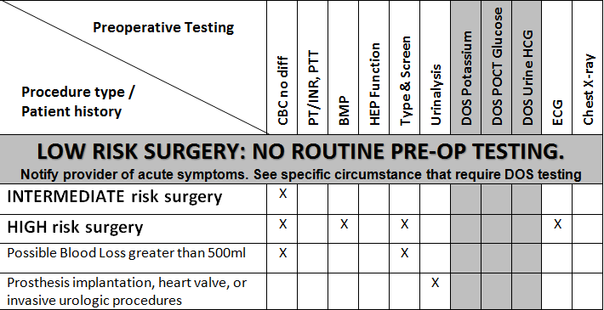
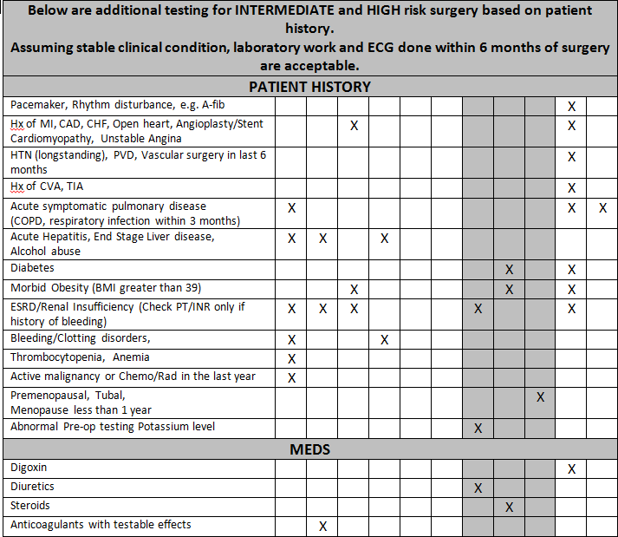

Procedure Examples by Surgical Risk

LOW RISK PROCEDURES: examples include
- Ambulatory Surgical Procedures **Excludes Laparoscopic Cholecystectomy**
- Endoscopic procedure/ Superficial procedures
- Cataract surgery
- Breast surgery
- Surgery on the arm or hand below the shoulder
- Surgery on the leg excluding major bone ORIF or Arthroplasty
INTERMEDIATE RISK PROCEDURES: examples include
- Head and Neck surgery
- Carotid Endarterectomy
- Intraperitoneal and Intrathoracic procedures
- Intra-abdominal = Laparoscopic Cholecystectomy & Nissen
- Robotic procedures
- Major orthopedic surgery (total joint or major bone ORIF)/ Includes Spinal Fusion or Multi- Level Laminectomy
HIGH RISK SURGICAL PROCEDURES: examples include:
- Major emergency procedures involving the head, chest or abdomen
- Major Vascular procedures
- Intracranial procedures
Procedures lasting > 3 hours, associated with large fluid shifts and/or blood loss (Whipple, Liver Resection, Large Oncology pro

