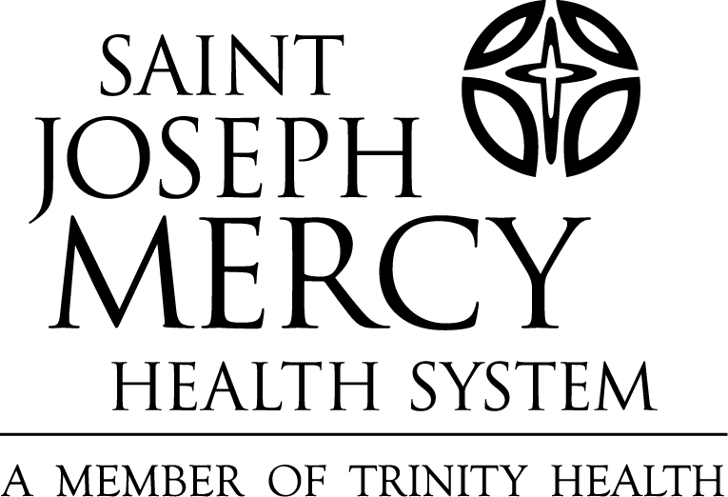

Conflict Avoidance Statement

Name:__________________________________________________________

Department:_____________________________________________________

Study Title/Number_______________________________________________

Sponsor/company:_________________________________________________

Due to my financial interest or monetary gains with this sponsor/company, I acknowledge that potential for a possible conflict of interest between the performance of my research and my personal financial interests as well as my contractual or other obligations to this sponsor/company. Therefore, I will not:

- restrict or delay general access to information from St. Joseph Mercy Health Systems Institutional Review Board (SJMHS IRB);
- alter the scope or direction of my research in order to materially benefit the company.

In addition, in order to avoid the appearance of a conflict, I will attempt to differentiate clearly between my SJMHS research and my involvement/contributions to the company/sponsor. To that end, I will report annually to the SJMHS Institutional Review Board the general nature of my activities on behalf of the company.

I understand that SJMHS may require me to disclose that I have a financial interest in the company in any publications or public statements I make should I present the research results for this study.

Signature_____________________________________________ Date_____________

Acknowledgement by department head_____________________ Date_____________

Acknowledgement by IRB Chairperson_____________________ Date_____________

