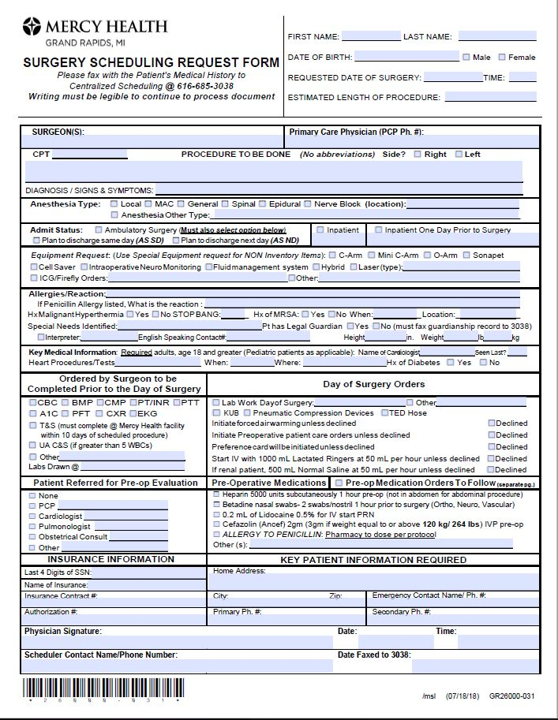

**↑ Day of Surgery Orders:** This is the **only** place to document day of surgery labs/orders otherwise they will be missed.

**↓ Admit Status:** If ambulatory surgery patient **MUST** also select either:

1. Plan to discharge Same Day OR

2. Plan to discharge next day)

We no longer will use Extended Stay Recovery as an Admit Type

**↑ Legal Guardian:** will **only** accept **current** guardianship paperwork.

**↑ Pre-operative Medications Orders to Follow: Must** check this box when sending a second page of Day of Surgery Medication Orders! Staff use this as their ALERT to anticipate the 2nd page of medication orders.

This is the only place to document Pre-operative Medication Orders otherwise they will be missed.

**↑ Equipment Requests:**  More options to select. Added ICG/Firefly orders.

This is the **only** place to document equipment requests otherwise they will be missed.

**↓ Anesthesia Type:**

Nerve Block (location): **include name of block**

Examples:  Nerve Block Axillary Block

Added Anesthesia Other Type:_____

**↑ Insurance Information:**  Only last 4 numbers of SSN.